13.5 Extracting of Fe
Name: ____________________ Class: ____________________ Due date: 6.5
1. Impure iron from the blast furnace is converted to steel as shown.
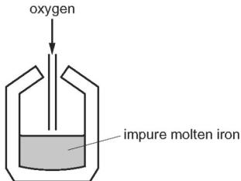
Which statement about the process is correct? （ ）
A Acidic oxides are added to remove alkaline impurities.
B Coke is added as a reducing agent.
C Oxygen is blown in to oxidise the impure iron.
D The steel produced contains less carbon than the impure iron.

2. Iron from a blast furnace is treated with oxygen and with calcium oxide to make steel.
Which substances in the iron are removed? （ ）
 | oxygen removes | calcium oxide removes
A | carbon | acidic oxides
B | carbon | basic oxides
C | iron | acidic oxides
D | iron | basic oxides

3. Four reactions that take place in the blast furnace to produce iron are shown.
Which reaction is used to keep the furnace hot? （ ）
A $C+O_{2}→{CO}_{2}$
B ${CO}_{2}+C→2CO$
C ${Fe}_{2}O_{3}+3C→2Fe+3CO$
D ${Fe}_{2}O_{3}+3CO→2Fe+3{CO}_{2}$

4. Iron is extracted from hematite in the Blast Furnace.
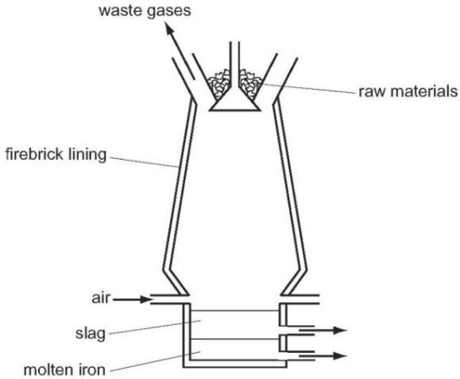
The hematite contains silica as an impurity.
What reacts with this impurity to remove it? （ ）
A calcium oxide B carbon C carbon dioxide D oxygen
5. The diagram shows a blast furnace.
In which part is iron ore changed to iron? （ ）
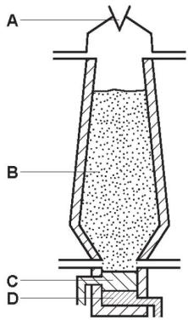

6. Which statement is incorrect? （ ）
A Carbon dioxide is a waste product in the extraction of iron.
B Carbon monoxide is a reducing agent.
C The extraction of iron from hematite involves reduction.
D When iron is converted into steel, oxygen is used to oxidise the iron.

7. Equations P and Q represent two reactions which occur inside a blast furnace.
$$\begin{aligned}&P {Fe}_{2}O_{3}+3CO→2Fe+3{CO}_{2} \\ &Q{ CaCO}_{3}→CaO+{CO}_{2}\end{aligned}$$
Which type of reactions are P and Q? （ ）
 | P | Q
A | redox | redox
B | redox | thermal decomposition
C | thermal decomposition | redox
D | thermal decomposition | thermal decomposition

8. Which substance is not involved in the extraction of iron from hematite? （ ）
A carbon B carbon monoxide C calcium carbonate D nitrogen

9. Iron is extracted from its ore in a Blast Furnace.
Hematite, coke, limestone and hot air are added to the furnace.
Which explanation is not correct? （ ）
A Coke burns and produces a high temperature.
B Hematite is the ore containing the iron as iron oxide.
C Hot air provides the oxygen for the burning.
D Limestone reduces the iron oxide to iron.

10. Iron is extracted from its ore, hematite, in the blast furnace.
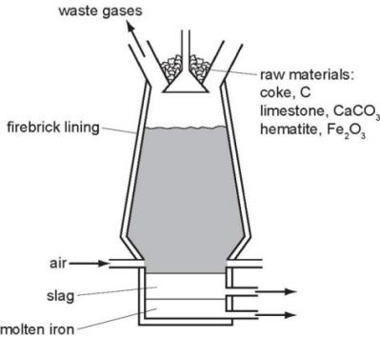
The temperature inside the blast furnace can rise to ${2000}^{∘}C$
Write an equation for the exothermic reaction which causes this high temperature.
.......................................................................................................................................
...................................................................................................................................[1]
Carbon monoxide is formed in the blast furnace. This reduces the ore hematite,${Fe}_{2}O_{3}$ to iron.
Explain how carbon monoxide is formed in the blast furnace.
.......................................................................................................................................................................................................................................................................... [2]
Write an equation for the reduction of hematite by carbon monoxide.
...................................................................................................................................[2]
Explain why it is necessary to add limestone, calcium carbonate, to the blast furnace. Include an equation in your explanation.
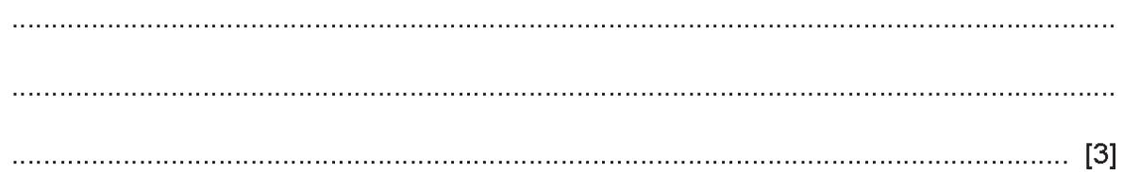
Most of the iron from the blast furnace is converted into mild steel.
A method of preventing the steel from rusting is coating it with zinc.
What is the name of this method of rust prevention?
..................................................................................................................................[1]
Explain, using the idea of electron transfer, why zinc- coated steel does not rust even when the coating is scratched and the steel is in contact with oxygen and water.
......................................................................................................................................
.......................................................................................................................................
...................................................................................................................................[3]

